**Set-of-5-Historical Places Framed Art**

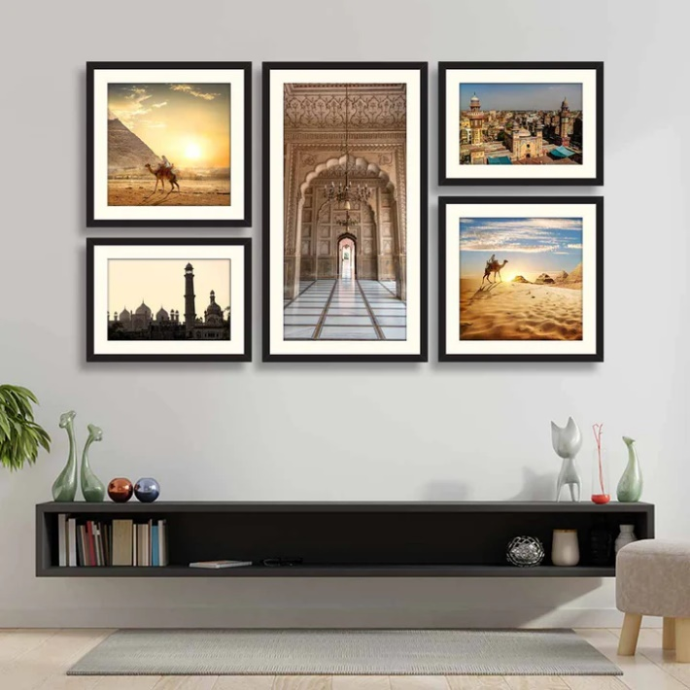The set of 5 historical places framed art brings timeless elegance and cultural richness to your space. Each piece showcases stunning illustrations or photographs of iconic landmarks, highlighting their architectural grandeur and historical significance. Encased in sleek frames, these artworks blend seamlessly with various decor styles, from traditional to modern. Perfect for history enthusiasts or travel lovers, this set adds depth and character to your walls, serving as both an aesthetic centrepiece and a conversation starter in your home or office.